1. Use the BrØnsted-Lowry definition for an acid and a base to identify the acids and bases in these equilibria, and their conjugate bases and acids.
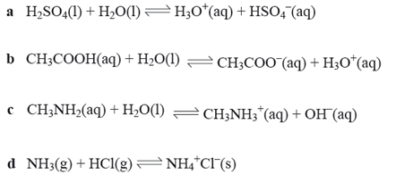

2. What does the low conductivity of water tell you about the number of ions available for carrying a direct current?
3. Experimental evidence tells us that the equilibrium constant for the reaction is very, very small. What does this tell you about the relative proportions of water molecules, protons and hydroxide ions? Does this fit in with your knowledge of the electrical conductivity of pure water?

4. Write balanced chemical equations and ionic equations for the following neutralisation reactions:
